|  |  |
| --- | --- |
| BLIND STICK  **SUBMITTED TO: MAAM IQRA ASHRAF** |  |

**pRESENTED BY:**

**Tariq Khan F24604060**

**Rohan Kumar F24604054**

**Muhammad Hamzah Iqbal F24604018**

**INTRODUCTION:**

Navigating the world without sight is a challenge millions face every day, and traditional tools like the white cane haven’t evolved much to meet modern needs. That’s why we created our blind stick—to be more than just a tool. It’s designed to empower, offering real-time guidance and obstacle awareness to help people move safely and confidently. Everyone deserves the freedom to explore the world on their own terms, and we have made an effort to make that possible.

**OVERVIEW:**

*Fig 1* is a circuit diagram that represents a basic obstacle detection system using an Arduino Uno, an ultrasonic sensor, an LED, and a buzzer. The system is powered via the Arduino’s USB connection. The ultrasonic sensor detects obstacles, while the LED and buzzer act as indicators to alert the user.

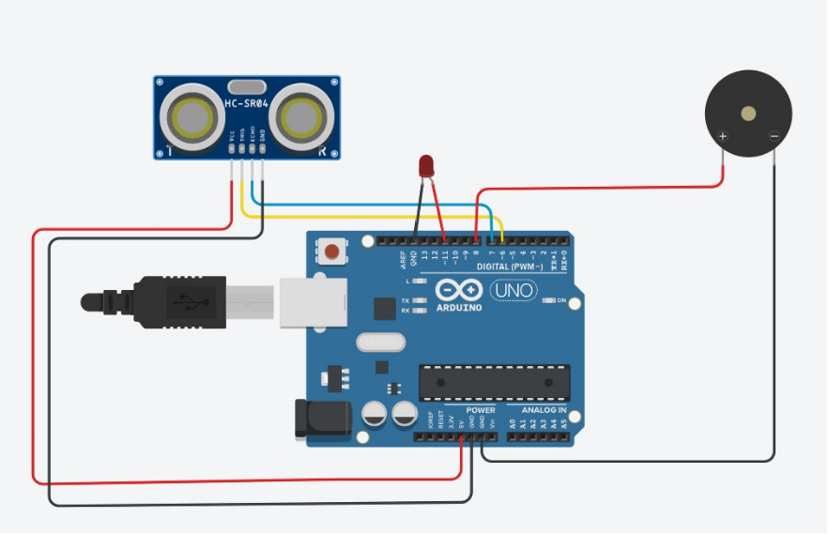

*Fig.1: Blind stick demo circuit*

**WORKING:**

The ultrasonic sensor emits ultrasonic waves and measures the time it takes for the waves to reflect back after hitting an obstacle. The sensor’s VCC and GND are connected to the Arduino’s power pins, while the Trig and Echo pins are connected to specific digital pins for signal transmission and reception. When the sensor detects an obstacle within a predefined range, the Arduino Uno processes this information and activates both the LED and the buzzer to alert the user visually and audibly.

*Fig.3: Implementation*

*Fig.2: Simulation*

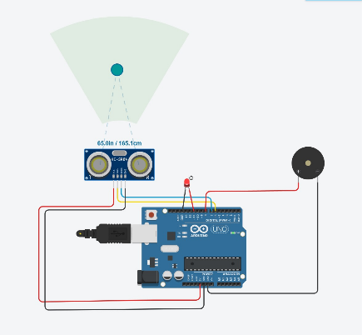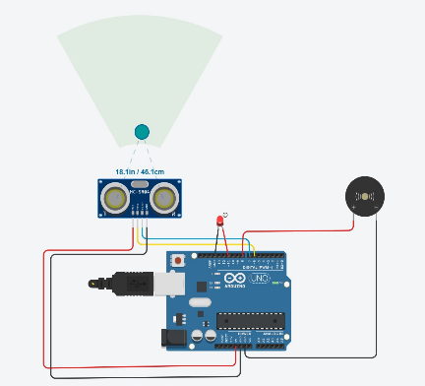

*Fig.3: Implementation*

*Fig.2: Simulation*

**COMPONENTS:**

|  |  |
| --- | --- |
|  | **Arduino Uno:**  The brain of the system, the Arduino Uno processes inputs from sensors (like ultrasonic sensors for detecting obstacles) and controls the outputs (like the buzzer and LED) based on the detected information. It ensures the functionality of the blind stick by managing the interactions between hardware components. |
|  | **Jumper Wires (8):**  These are used to connect the various electronic components (such as the Arduino, sensors, buzzer, and LED) to each other and to the power supply, facilitating the proper flow of electricity and signals. |
|  | **DC Buzzer (3V):**  The buzzer provides an audible alert to the user when an obstacle is detected in front of the blind stick. It helps in guiding the user by producing sound cues to avoid collisions. |
|  | **PVC Pipe:**  The PVC pipe forms the body of the blind stick. It's lightweight, durable, and easy to handle, allowing the user to hold and maneuver the stick with ease. |
|  | **LED:**  The LED serves as a visual indicator, lighting up to signal the user about the proximity of obstacles. It works in conjunction with the buzzer to provide both visual and auditory feedback. |
|  | **Cable Ties:**  These are used to secure and organize the components (like sensors, wires, and the buzzer) to the PVC pipe, ensuring everything is in place and preventing any loose wires that could cause malfunctions. |

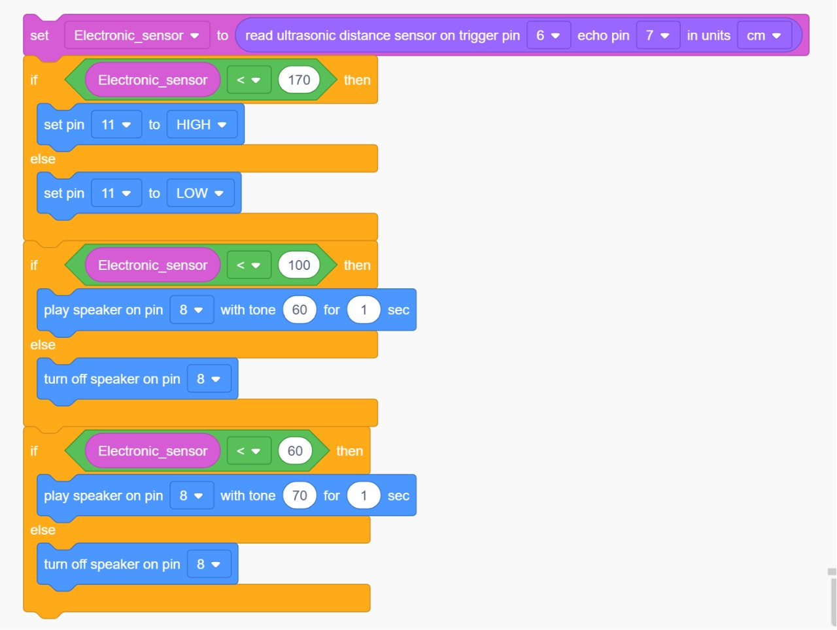**SCRATCH CODE:**

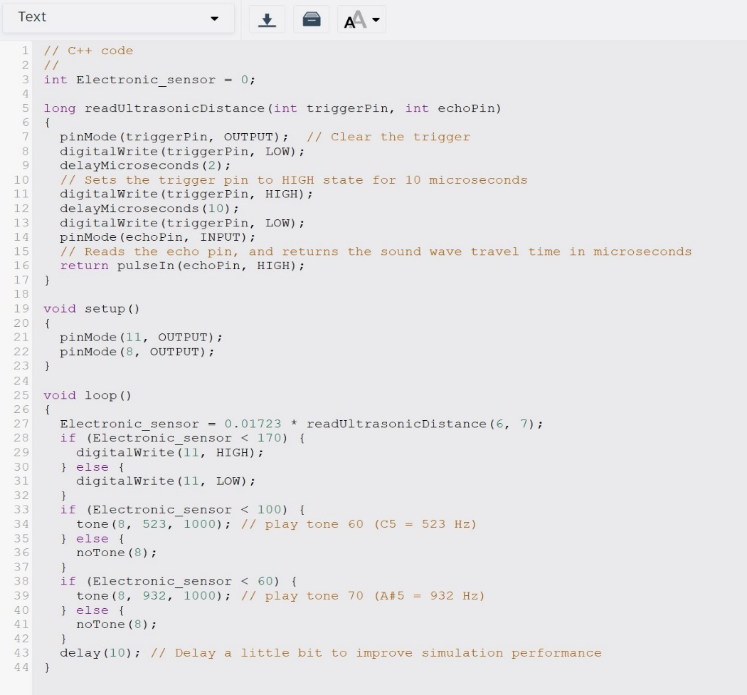**Arduino IDE Code:**

**BLIND STICK:**

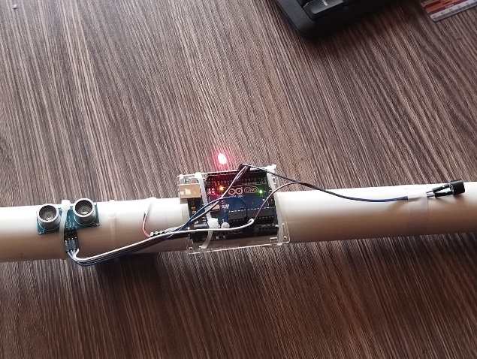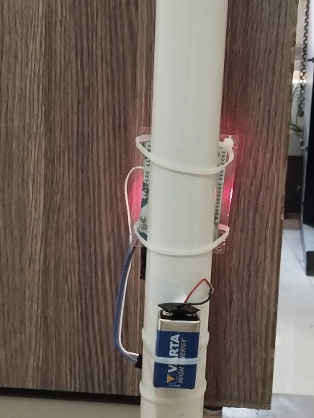

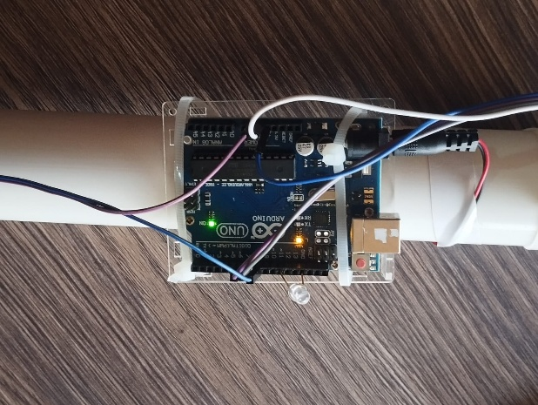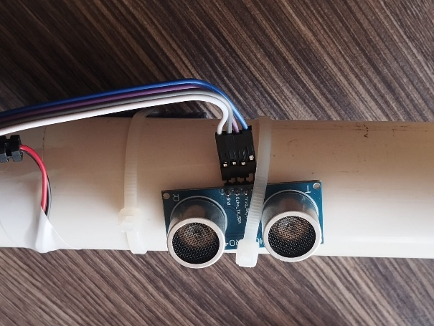

**____________________________________________________________________________________**

**CONCLUSION:**

In conclusion, the blind stick innovation combines simple technology to enhance the mobility and safety of visually impaired individuals. By using components like the Arduino Uno, sensors, and feedback systems, it helps users detect obstacles, improving their confidence in navigation.